THE UNIVERSITY OF BRITISH COLUMBIA

Department of Electrical and Computer Engineering

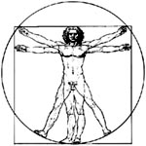

**RADIO PROJECT REPORT**

prepared by

Lab Group 2

Michael Marchesi 15043169

Dhruval Shah 10888155

Rayhan Bosch 28084151

Sean Lam 19839159

in Partial Fulfillment of the Requirements for

ELEC 391 – Electrical Engineering Design Studio II

Date performed: 27 Jul 2018

Date submitted: 4 Aug 2018

# Abstract

In this project, we aimed to construct a simple AM radio receiver that could clearly tune into at least two stations from Vancouver. We improved the basic radio given to us in the following three categories: sensitivity, selectivity and distortion. The capacitor and inductor used in the resonance circuit obtained high Q-factors, and thus high selectivity, at high capacitances and inductances. For sensitivity, the Germanium diode gives better input-to-output power ratios than the MBR150 Schottky diode in the envelope detector circuit. The MBR150 diode has an internal resistance and forward voltage drop that causes more losses than the Germanium diode. As a result, the Germanium diode was used in the AM radio receiver to improve sensitivity. For distortion, the signal at output of the envelope detector was distorted, which is related to the Germanium diode’s non-linear biasing. Furthermore, the signal at the output of the audio amplifier is also distorted due to the internal circuitry in the audio amplifier. To reduce distortion, consider using a low distortion audio amplifier and a precision rectifier. Using the theory and practical knowledge we acquired in this experiment, we were successful in making an AM radio receiver that is tunable to four distinct stations with very good quality.

**Table of Contents**

Abstract ii

List of Figures iv

List of Tables v

Glossary vi

List of Abbreviations vii

INTRODUCTION 1

1 IMPROVING SELECTIVITY OF THE AM RECIEVER 2

1.1 Introduction 2

1.2 Procedure 2

1.3 Results 3

1.4 Discussion 5

2 IMPROVING SENSITIVITY OF THE AM RECEIVER 6

2.1 Introduction 6

2.2 Procedure 6

2.3 Results 8

2.4 Discussion 10

3 IMPROVING DISTORTION OF THE AM RECEIVER 11

3.1 Introduction 11

3.2 Procedure 11

3.3 Results 13

3.4 Discussion 16

CONCLUSIONS AND RECOMMENDATIONS 17

Conclusions 17

Recommendations 18

4 REFERENCES 19

# List of Figures

Figure 1‑1 Circuit schematic for the parallel resonance circuit 3

Figure 1‑2 (a) Internal resistances as inductance increases, (b) Relation between Q-factor and inductance 3

Figure 1‑3 (a) Internal resistances as a function of capacitances, (b) Q-factor increases as capacitance increases. 4

Figure 1‑4 (a) Frequency response of parallel resonant circuit at highest component values (L = 505.7 μH; C = 352.3 pF), (b) Frequency response of parallel resonant circuit at lowest component values (L = 59.2 μH; C = 15.6 pF), (c) Frequency response of parallel resonant circuit at intermediate component values (L = 301.9 μH; C = 202.1 pF) 4

Figure 2‑1 Fully optimized AM radio receiver circuit 7

Figure 2‑2 Input-to-output power transfer characteristics with Germanium diode and not short circuiting 10kΩ resistor 8

Figure 2‑3 Input-to-output power transfer characteristics with Germanium diode and short circuiting 10kΩ resistor 8

Figure 2‑4 Input-to-output power transfer characteristics with MBR150 diode and short circuiting 10kΩ resistor 9

Figure 2‑5 Output of envelope detector with Germanium diode 9

Figure 2‑6 Output of envelope detector with MBR150 diode 9

Figure 2‑7 AM receiver circuit for best selectivity. 10

Figure 3‑1 Schematic of low power radio with our improvements 12

Figure 3‑2 Oscilloscope screen capture at point A (non-short circuited) 13

Figure 3‑3 Spectrum Analyzer screen capture at point A (non-short circuited) 13

Figure 3‑4 Oscilloscope screen capture at point B (non-short circuited) 14

Figure 3‑5 Spectrum Analyzer screen capture at point B (non-short circuited) 14

Figure 3‑6 Spectrum Analyzer screen capture at point A (short circuited) 15

Figure 3‑7 Spectrum Analyzer screen capture at point B (short circuited) 15

# List of Tables

Table 1‑1 List of equipment for experiment 1. 2

Table 2‑1 List of components used in this experiment. 6

Table 2‑2 List of equipment used for this experiment. 7

Table 3‑1 Equipment used in experiment three 11

Table 3‑2 List of components used in this experiment 11

# Glossary

|  |  |
| --- | --- |
| Selectivity | Measure of the performance of a radio receiver to respond to only the signal that it is tuned to and reject other signals in a nearby frequency. The quality factor (Q-factor) is another way of defining the selectivity. |
| Sensitivity­ | Minimum magnitude of input signal required to produce a specified output signal with a specific signal to noise ratio. |
| Distortion | Alteration in the waveform of an information bearing signal. |
| Signal to Noise Ratio | Ratio that compares the level of a desired signal to the level of background noise. |
|  |  |
|  |  |
|  |  |

# List of Abbreviations

|  |  |
| --- | --- |
| AM | Amplitude Modulation |
| RF | Radio Frequency |
| LPF  BCB | Low Pass Filter  Broadcast Band |
|  |  |
|  |  |

# INTRODUCTION

Over the course of this project, we performed a series of experiments to allow us to design and optimize low power radio receiver that could tune into several AM BCB stations based in Vancouver. Given the basic radio circuit, we studied and analyzed its’ selectivity, sensitivity and distortion. This project report illustrates the improvements that were made in those categories. The details are divided into the following sections:

In section one, we studied the effects of varying inductance and capacitance values on the Q factor of the resonance circuit. By establishing the best inductor and capacitor values, we were able to create a frequency response plot which allows us to determine the circuit that has the best selectivity.

In section two, we examined the input and output power levels to establish the optimal sensitivity of our AM receiver. The full AM radio receiver circuit implemented an envelope detector – this portion of the circuit was the major focus of this section. The envelope detector was used to determine the input-output power transfer characteristics our of circuit. We studied and tabulated the effects of interchanging the MBR150 diode and the Germanium diode.

In section three, we measured the output of various points in the circuit and compared them to the message signal that was the input to the circuit. We measured the outputs on both the oscilloscope and spectrum analyzer, and from this we were able to define and visualize the distortion each component was adding to the circuit.

Finally, we draw conclusions from our experience in designing a low power AM receiver that can clearly tune into several radio stations and offer recommendations for anyone looking to replicate or improve upon our design.

# IMPROVING SELECTIVITY OF THE AM RECIEVER

## Introduction

A resonance circuit is implemented at the input of our circuit to construct a selective receiver. The resonance circuit is simply an inductor and a capacitor connected in a parallel connection. With the overall target of being able to clearly tune into one station at any given time, we addressed the following objectives in this experiment:

1. Measured and characterized internal resistances and Q-factors of the inductor and variable capacitor with varying inductance and capacitance values
2. Characterized the frequency response of the parallel internal resistances and Q-factors of the inductor and variable capacitor with varying inductance and capacitance values
3. Estimated the Q-factor and bandwidth with each frequency response and suggested improvements for selectivity

## Procedure

Table 1-1 contains a list of equipment used for this experiment:

Table 1‑1 List of equipment for experiment 1.

|  |  |
| --- | --- |
| Equipment | Model Number / Serial Number |
| RCL Meter | Fluke PM6303A RCL Meter / DG1D181701878 |
| Dual Channel Oscilloscope | Tektronix, TDS 2012C, 100 MHz / TDS2012 C042585 |
| Waveform Function Generator | Rigol, DG1022, 2 Channel / DG1D181701878 |
| Power Supply | Xantrex XPH 35-4T / J00212723 |

We followed the below procedure for acquiring the data for this experiment:

1. We changed the capacitance and inductance values from minimum to maximum, while recording the following:
   1. Internal series and parallel resistances
   2. Q-factor
   3. Capacitance/inductance
2. Assembled the parallel resonance circuit with a 100 Ω current sense resistor (R1) and the source at 15 V peak-to-peak as shown in Figure 1-1:

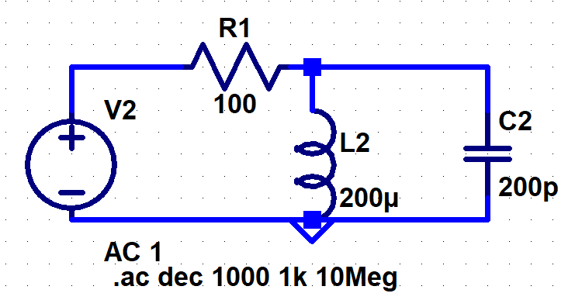

Figure 1‑1 Circuit schematic for the parallel resonance circuit

1. Measured the resistance of R1, for more accurate results.
2. We set the capacitance and inductance values to
   1. Minimum
   2. Maximum
   3. Intermediate
3. Probed the voltage before the current sense resistor (CH1) and after the resistor (CH2)
4. Used the ‘MATH’ function on the oscilloscope to obtain peak-to-peak voltage (Vpp) across the resistor while increasing the frequency logarithmically.
5. Knowing the voltage across the current sense resistor, the current through the power supply was calculated using Ohm’s law. The power output of the power supply was then calculated using,

(1.1)

1. Obtained a frequency response of the power output from the source versus frequency.

## Results

Figure 1.2 (a) is a plot that illustrates the relationship between the internal resistances and the inductance of the variable inductor. Similarly, Figure 1.2 (b) illustrates the increase in Q factor as the variable inductance increases.

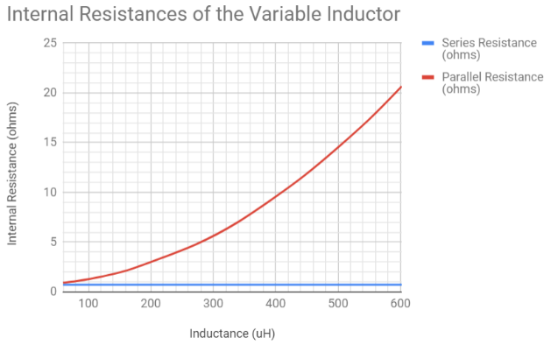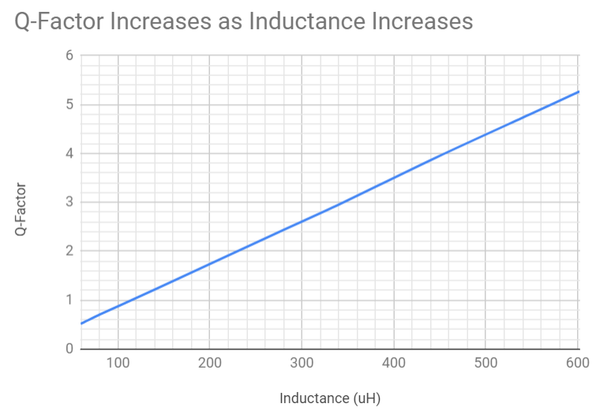

1. (b)

Figure 1‑2 (a) Internal resistances as inductance increases, (b) Relation between Q-factor and inductance

Figures 1.3 (a) and (b) show the relationships between increasing capacitance with internal resistances and Q factor, respectively.

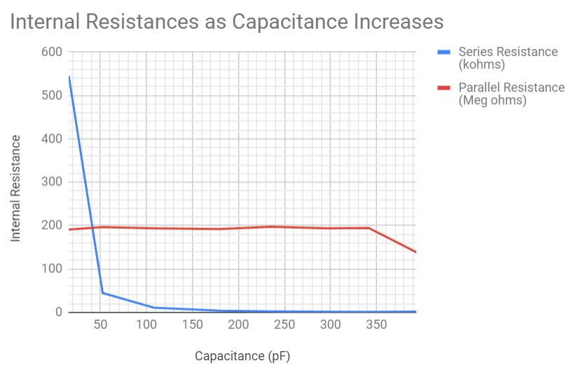.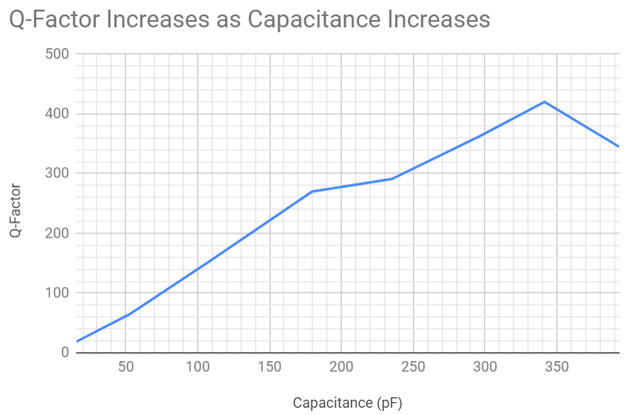

1. (b)

Figure 1‑3 (a) Internal resistances as a function of capacitances, (b) Q-factor increases as capacitance increases.

Figures 1-4 (a), (b), and (c) illustrate the frequency response at various inductance and capacitance values:

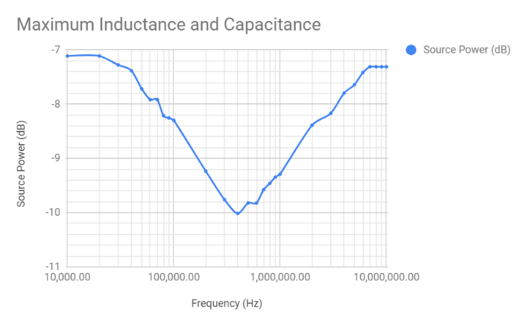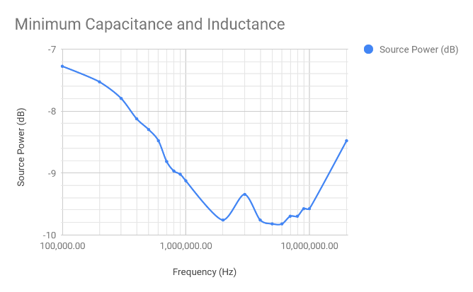

1. *(b)*

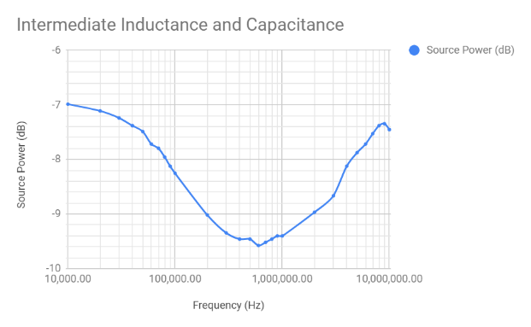

*(c)*

Figure 1‑4 (a) Frequency response of parallel resonant circuit at highest component values (L = 505.7 μH; C = 352.3 pF), (b) Frequency response of parallel resonant circuit at lowest component values (L = 59.2 μH; C = 15.6 pF), (c) Frequency response of parallel resonant circuit at intermediate component values (L = 301.9 μH; C = 202.1 pF)

## Discussion

From Figure 1-2 (a), the parallel resistance increases as inductance increases, which indicates the effects of utilizing the ferrite core. Furthermore, the series resistance remains relatively the same because the dimensions and the properties of the wire have not changed. This can be demonstrated mathematically, by using equation (1.2).

The theoretical Q-factor [1] is known to be:

(1.2)

where is the given angular frequency, L is the inductance and R is the internal series resistance of the component. The Q-factor increases linearly as the inductance increases because the series resistance and the test frequency stay the same. From Figure 1-2 (b), the observed trend for the Q factor and the inductance matches with the predictions derived from theory. From Figure 1-3 (a), the series resistance decreases dramatically as capacitance increases while the parallel resistance remains relatively the same. As previously, the theoretical Q-factor is:

(1.3)

The Q-factor increases depending on how the resistance and capacitance change. Based on Figure 1-3 (b), the Q-factor increases as capacitance increases because the internal resistances are lower.

The Q-factor of a parallel resonant circuit is a measure of the circuit’s selectivity and can be estimated using the bandwidth (3 dB points) and its resonant frequency [2]. Comparing the frequency responses in Figure 1.4 (a), (b), and (c), the Q-factor of the parallel resonant circuit is the best when the inductance and capacitance are at the highest values (505.7 µH and 352.3 pF respectively) and the worst when the inductance and capacitance are at their lowest values (59.2 µH and 15.6 pF respectively). Thus, the selectivity is higher at higher inductances and capacitances and lower at lower inductances and capacitances.

For the AM radio, a low selectivity means more crosstalk between AM radio channels. With higher selectivity, less crosstalk occurs, and one can listen to one radio channel clearly. Improvements were made to the selectivity by keeping the inductances and capacitances at higher values but still tunable to the AM radio broadcast band (535 kHz – 1705 kHz).

# IMPROVING SENSITIVITY OF THE AM RECEIVER

## Introduction

In this experiment, we constructed the complete AM radio circuit and measured the input-to-output power levels to characterize the sensitivity of our AM receiver. We addressed the following objectives:

1. Characterized input-output power transfer characteristics of our envelope detector and full radio circuit
2. Compared input-output power transfer characteristics of our envelope detector and full radio circuit with:
   1. MBR150 Schottky diode in the envelope detector
   2. Germanium diode in the envelope detector
   3. Short circuiting the resistor in the envelope detector
   4. Not short circuiting the resistor in the envelope detector

Based on the results of this experiment, we determine how to optimize the sensitivity of our circuit and we suggest improvements based on our observations.

## Procedure

Table 2-1 tabulates the components needed to perform this experiment:

Table 2‑1 List of components used in this experiment.

|  |  |
| --- | --- |
| Components | Values/Model Numbers |
| Antenna | N/A |
| Inductor | 505.7 µH |
| Capacitors | 352.3 pF, 1 nF (Silver Mica), 10 µF, 0.05 µF and 250 µF |
| Germanium Diode | 1N34A Diode |
| Resistors | 10 kΩ (2 Potentiometers), 10Ω |
| Potentiometers | 10 kΩ |
| Audio Amplifier | LM386 |
| Output Speakers | Low Resistance (~50Ω) |
| Breadboard | N/A |

Table 2-2 contains a list of equipment used to gather the data for the analysis of this experiment:

Table 2‑2 List of equipment used for this experiment.

|  |  |
| --- | --- |
| Equipment | Model Number / Serial Number |
| RCL Meter | Fluke PM6303A RCL Meter / DG1D181701878 |
| Dual Channel Oscilloscope | Tektronix, TDS 2012C, 100 MHz / TDS2012 C042585 |
| Waveform Function Generator | Rigol, DG1022, 2 Channel / DG1D181701878 |
| Power Supply | Xantrex XPH 35-4T / J00212723 |
| RF Generator | Agilent, 8648B, 9 kHz - 2 GHz / 3847M01134 |
| Spectrum Analyzer | Rigol, DS815 / DSA8A191600297 |

We followed the procedure outlined below, to obtain the necessary data for this experiment:

1. We set up the radio circuit as the following:  
     
   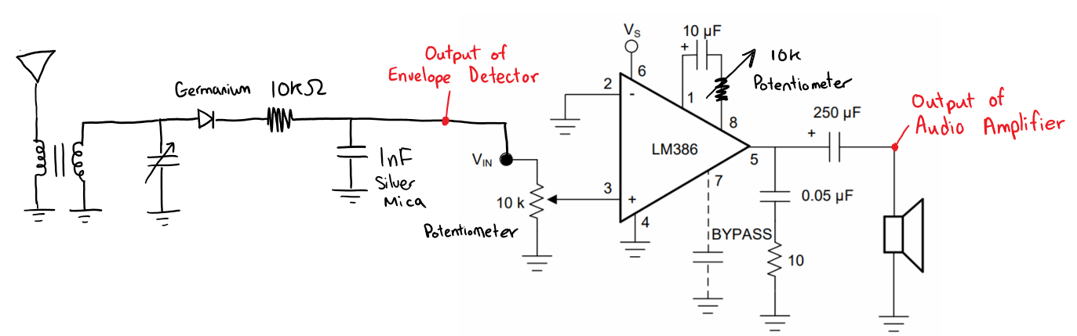

Figure 2‑1 Fully optimized AM radio receiver circuit

The transformer was created by wrapping the antenna wire around the inductor and wiring it in a parallel connection to the variable capacitor, on the breadboard.

1. We removed the resonant circuit portion of the radio circuit (variable capacitor, transformer, and antenna), to test the sensitivity of our design.
2. We set up RF Signal Generator to connect to the Germanium diode in the AM radio circuit with the following settings:
   1. Carrier: 1.705 MHz with varying power from -37 dBm to 12 dBm
   2. Modulating: 5 kHz at 1 V peak-to-peak
   3. Modulation index: 50%
3. Then, we connected the spectrum analyzer to the output of the audio amplifier.
4. We measured the output power as the input power is stepped up by 3 dBm with:
   1. MBR150 Schottky diode in the envelope detector, without the 10kΩ resistor in the envelope detector.
   2. Germanium diode in the envelope detector, with and without the 10kΩ resistor in the envelope detector.
5. We characterized the input-to-output power transfer function of the audio amplifier, using the spectrum analyzer.
6. We performed the input-to-output power measurement with the spectrum analyzer connected to the output of the envelope detector.

## Results

Figures 2-2 and 2-3 illustrate the relationship between the output and input power, in dBm, of the Germanium diode, with and without the 10 kΩ resistor:

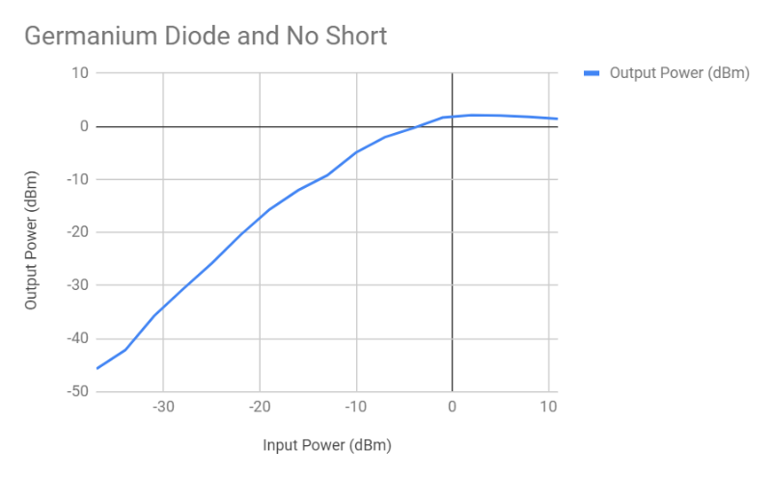

Figure 2‑2 Input-to-output power transfer characteristics with Germanium diode and not short circuiting the 10 kΩ resistor

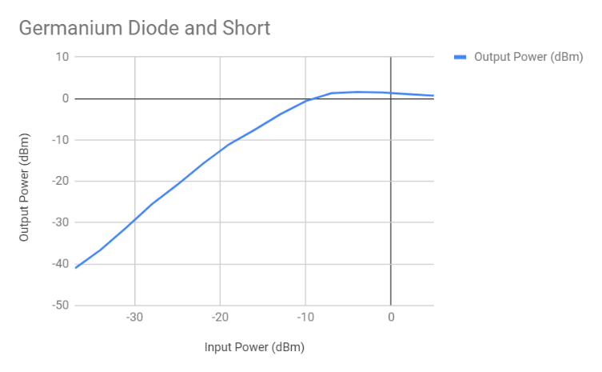

Figure 2‑3 Input-to-output power transfer characteristics with Germanium diode and short circuiting the 10 kΩ resistor

Figure 2-4 illustrates the power transfer characteristic of the circuit with the MBR150 diode and not having the 10 kΩ resistor:

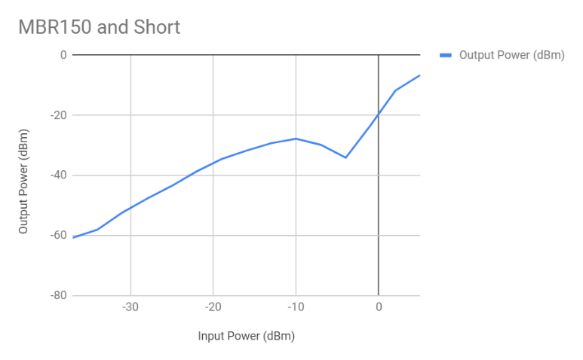

Figure 2‑4 Input-to-output power transfer characteristics with MBR150 diode and short circuiting 10 kΩ resistor

Figures 2-5 and 2-6 show the output of the envelope detector using the Germanium and the MBR150 diodes (see Figure 2-1 for measurement point), as measured by the spectrum analyzer:

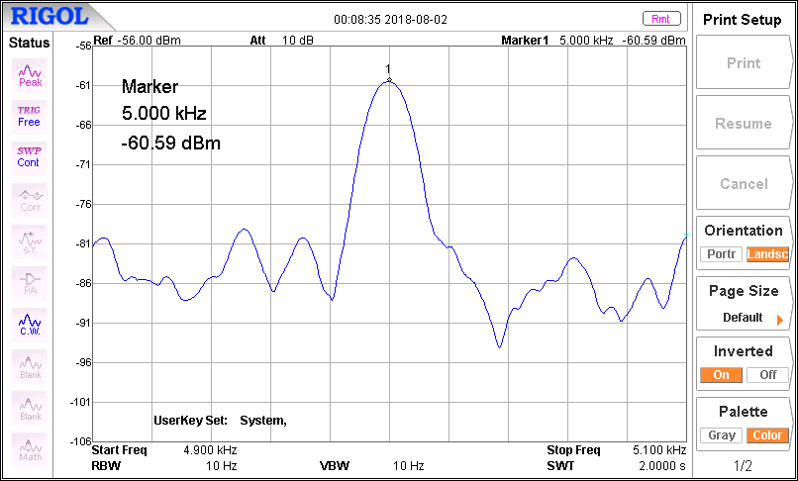

Figure 2‑5 Output of envelope detector with Germanium diode

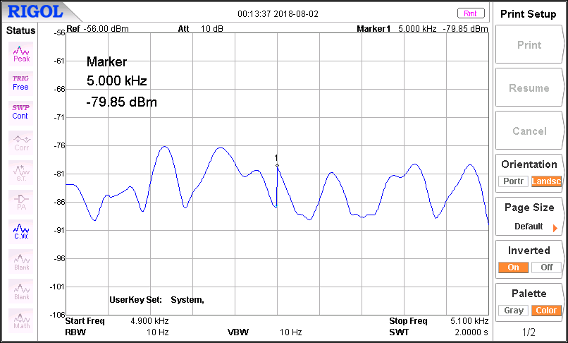

Figure 2‑6 Output of envelope detector with MBR150 diode

## Discussion

Comparing Figure 2‑5 and Figure 2‑6, the output power of the Germanium diode is measurable whereas the output power from the MBR150 diode is immeasurable, meaning the MBR150 has large losses that attenuate the input signal. The likely cause of the MBR150’s attenuation originates from its forward voltage drop and internal resistance, which is higher than the Germanium diode and causes attenuation of the input signal. Comparing the output power levels in Figure 2‑3 and Figure 2‑4, the Germanium diode output power is always higher than the MBR150 diode output power. Furthermore, the input-to-output power characteristics of the Germanium diode is more linear than the input-to-output power characteristics of the MBR150. Therefore, the Germanium diode has better sensitivity characteristics and is preferred over the MBR150 (the best contending Schottky diode) when constructing the AM radio circuit. Comparing Figure 2‑2 and Figure 2‑3, short circuiting the 10 kΩ resistor in the envelope detector increases the output power. The 10 kΩ resistor takes up some power and attenuates the input signal, which decreases the output power. Therefore, the sensitivity increases when the 10 kΩ resistor is short circuited because less losses occur. To improve sensitivity in the AM radio circuit, we use the Germanium diode and short circuit the 10 kΩ resistor in the envelope detector. Our circuit for optimal selectivity looks as shown in Figure 2-7:

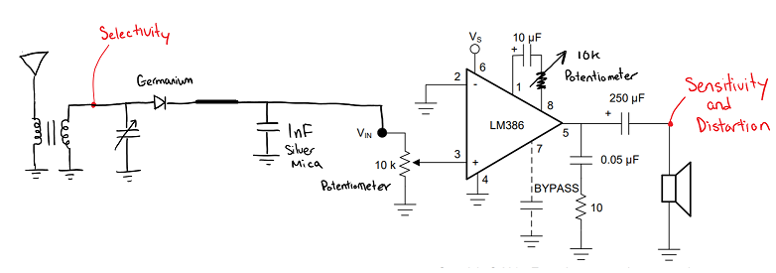

Figure 2‑7 AM receiver circuit for best selectivity.

# IMPROVING DISTORTION OF THE AM RECEIVER

## Introduction

In this section, our aim was to:

1. measure the effects of distortion on the output of the LPF and the Audio Amplifier

We established a method to quantitatively measure the amount of distortion present due to these components, using the oscilloscope and spectrum analyzer. These two measuring points were selected as they are both important segments of our radio circuit and they were having the greatest effect on the distortion of the signal.

## Procedure

Table 3-1 contains a list of equipment used in this experiment:

Table 3‑1 Equipment used in experiment three

|  |  |  |
| --- | --- | --- |
| Equipment | Model Number | Serial Number |
| Waveform Generator | Rigol, DG1022, 2 Channel | DG1D181701878 |
| Dual-Channel Oscilloscope | Tektronix, TDS 2012C, 100 MHz | TDS2012 C042585 |
| RF Signal Generator | Agilent, model 8648B, 9 kHz - 2 GHz | 3847M01134 |
| Spectrum Analyzer | Rigol, model DS815 | DSA8A191600297 |

Table 3-2 contains a list of components used to assemble the circuit shown in Figure 3-1:

Table 3‑2 List of components used in this experiment

|  |  |
| --- | --- |
| Components | Values/Model Numbers |
| Antenna | N/A |
| Inductor | 505.7 µH |
| Capacitors | 352.3 pF, 1 nF (Silver Mica), 10 µF, 0.05 µF and 250 µF |
| Germanium Diode | 1N34A Diode |
| Resistors | 10 kΩ (2 Potentiometers), 10Ω |
| Potentiometers | 10 kΩ |
| Audio Amplifier | LM386 |
| Output Speakers | Low Resistance (~50Ω) |
| Breadboard | N/A |

The below procedure was followed to measure the distortion of our circuits at various points:

1. We connected the RF Signal Generator’s output to radio’s antenna port.
2. We connected the Rigol Signal Generator’s output to the modulating input of RF Signal Generator.
3. We set the Rigol Signal Generator to output a 1 kHz, 1 sinusoidal signal, with an output impedance of 600 Ω.
4. We set the RF signal generator to 1.705 MHz, 50% modulating index.
5. We tuned the radio to 1.705 MHz.
6. We connected the oscilloscope to point (A).
7. We adjusted the output display accordingly and observed and recorded any distortions to the sinusoidal wave.
8. We connected the spectrum analyzer to point (A).
9. We adjusted the output display accordingly and observed and recorded attenuated signals at 1.705 MHz.
10. We repeated steps 6 through 9 at point (B).
11. We short circuited the 10 kΩ resistor before point (A).
12. We repeated steps 8 and 9 at point (B).

Figure 3-1 shows the schematic of our circuit for this experiment:

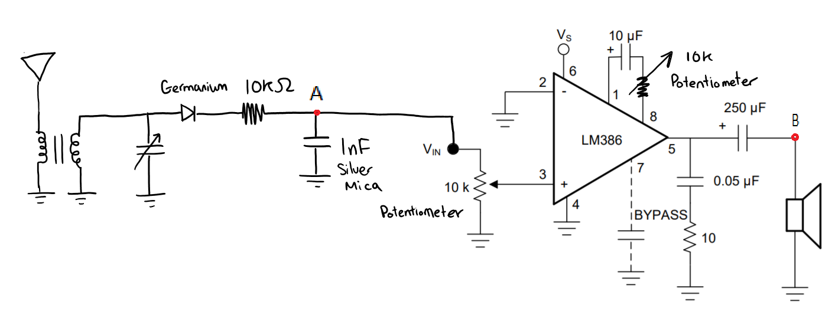

Figure 3‑1 Schematic of low power radio with our improvements

## Results

Figures 3-2 to 3-7 are screen captures of both the oscilloscope and spectrum analyzer under various conditions:

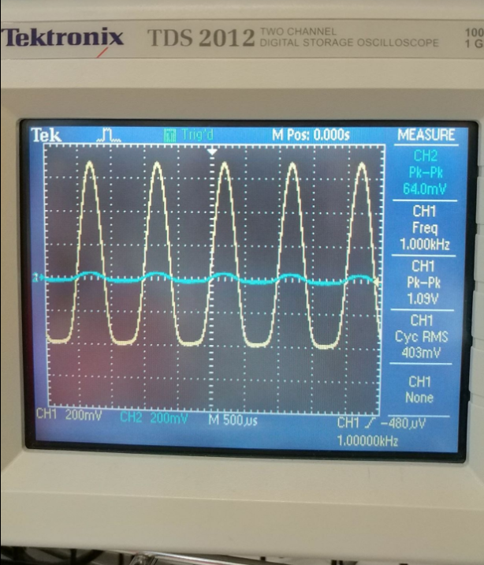

Figure 3‑2 Oscilloscope screen capture at point A (non-short circuited)

In Figure 3‑2, CH2 (blue) shows the message signal provided by the Rigol Waveform Generator, while CH1 (yellow) shows the output of the low pass filter, which also serves as the input to the audio amplifier.

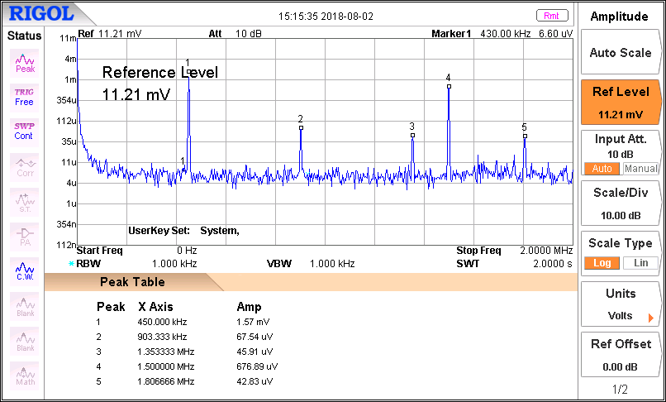

Figure 3‑3 Spectrum Analyzer screen capture at point A (non-short circuited)

Figure 3‑3 shows that the first harmonic in the Spectrum Analyzer screen capture of point A is at 433.3 kHz, with all the other harmonics appearing in multiples of this frequency, which is to be expected.

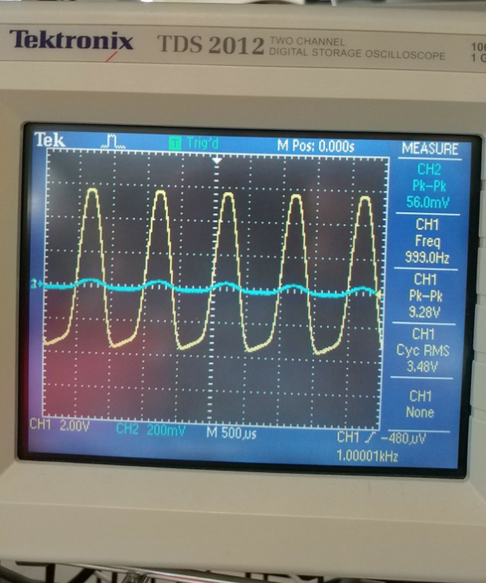

Figure 3‑4 Oscilloscope screen capture at point B (non-short circuited)

In Figure 3‑4, CH2 (blue) is again the message signal that is being input into the radio from the Rigol Signal Generator, while CH1 (yellow) is the output of the audio amplifier. Also note that the amplitude scales are not uniform for this figure, as the oscilloscope was not able to show the relationship between the input and output when the amplitude scales were calibrated to be equal.

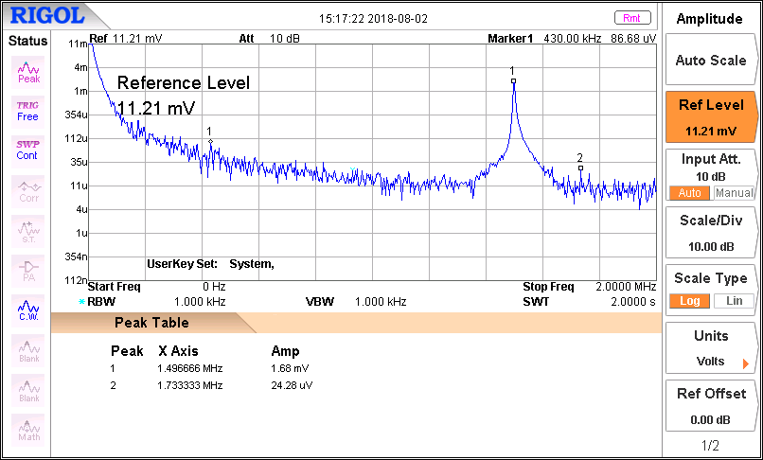

Figure 3‑5 Spectrum Analyzer screen capture at point B (non-short circuited)

For Figure 3‑5, peaks 1 through 5 are a part of the noise floor and thus negligible when doing analysis of the output display of the spectrum analyzer. There is a spike in the frequency at 1.7333 MHz, which is what we set the RF Signal Generator to.

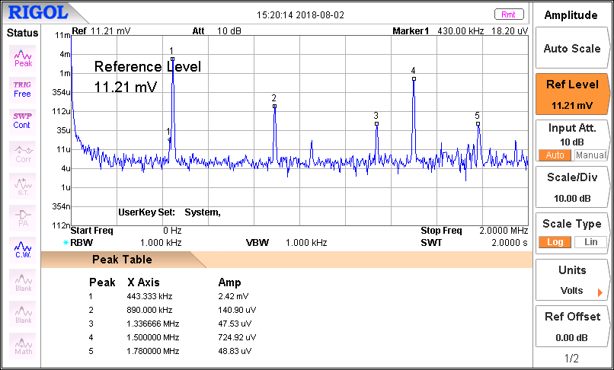

Figure 3‑6 Spectrum Analyzer screen capture at point A (short circuited)

We then short circuited the 10 kΩ resistor before point B and observed the outputs on the Spectrum Analyzer at point A, as shown in Figure 3‑6. As expected, the harmonics are still occurring at the same frequency interval of 443.33 kHz, but the amplitude at each harmonic is now larger.

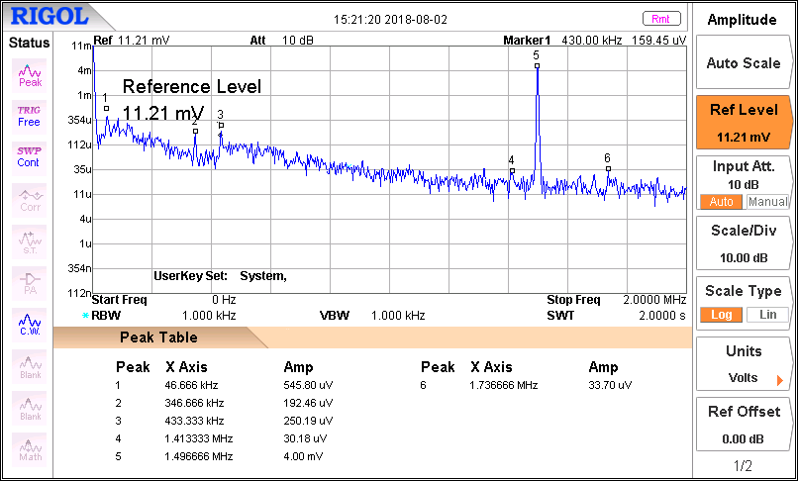

Figure 3‑7 Spectrum Analyzer screen capture at point B (short circuited)

Likewise, the spike that occurs at 1.733 MHz in the circuit that is not short circuited occurs at 1.73666 MHz in the shorted circuit, as seen in Figure 3‑7. The amplitude is also greater than it was in the shorted circuit, at 33.7 μV, whereas it was 24.28 μV in the non-shorted circuit.

## Discussion

A message is distorted when any change to the original waveform occurs. As seen in Figure 3‑2, when the message signal, depicted in CH2 (blue), goes through the LPF, the amplitude gets multiplied by a gain of roughly 20, with the amplitude of the message signal being 64 mV, or 0.064 V, while the amplitude of the output is 1.09 V. However, the signal is not perfectly amplified, as seen by the rounding on the peaks and troughs. The peaks are much sharper than the troughs, and this is a method of showing the distortion of a component visually, as it is obvious that the output of the LPF is not a perfect sinusoid and is thus distorted.

Likewise, when analyzing the output of the audio amplifier in Figure 3‑4, we can see an asymmetry on the amplitude axis that indicates that the output signal is distorted. The input message signal has an amplitude of 56 mV, or 0.056 V, and the output of the audio amplifier has an amplitude of 9.28 V, which is an amplification of roughly 166.

Both oscilloscope screen captures discussed are of the circuit exactly as in the schematic shown in Figure 3‑1. However, if we short circuit the 10 kΩ resistor before point A, we can compare the spectrum analyzer screen captures at points A and B. The screen captures at point A both before (Figure 3‑3) and after the short circuiting (Figure 3‑6) are nearly identical, with the shorted circuit having a higher amplitude at each of the same harmonic frequencies. The same is true for the screen captures at point B before and after short circuiting (Figure 3‑5 and Figure 3‑7 respectively).

These results could be due to several factors, but the most likely one is that the Germanium diode we used has a non-linear biasing, and this could be what is causing the distortion. Another likely cause could be the internal circuitry of the audio amplifier, which we have not accounted for in our analysis.

# CONCLUSIONS AND RECOMMENDATIONS

## Conclusions

This project report outlines the details of our experience in designing and constructing a low power radio receiver that is capable of tuning into several AM BCB stations from Vancouver. We began with the basic circuit presented to us in Lab 5 and made improvements in three major categories: selectivity, sensitivity, and distortion. To create a successful receiver, we designed the circuit in modular stages, which can be seen in Figure 3-1. The circuit is composed of a transformer, a resonance circuit, an envelope detector, and an audio amplifier. Each stage has a unique functionality which contributes to the overall circuit design. This can be further examined by each experiment presented in the three major sections of this report.

The first experiment studies the characteristics of the resonance circuit that was constructed by wiring an inductor and a variable capacitor in a parallel connection. We considered the non-ideal, internal resistances of the inductor and capacitor and studied the effects of various capacitance and inductance values on the Q-factor. This is significant because the Q-factor directly relates to the selectivity of your circuit – to design a highly selective circuit, we must ensure a high Q-factor. Likewise, a more selective circuit means less crosstalk between stations operating on adjacent frequencies. Our analysis of our results showed us that the largest Q-factor is achieved when we select the inductance and capacitance values at their maximum (505.7 µH and 352.3 pF respectively) and the smallest Q-factor is achieved when the inductance and capacitance are at their minimum values (59.2 µH and 15.6 pF respectively).

The second experiment studies the sensitivity of the envelope detector and full radio circuit with varying diodes and envelope detector configurations. The MBR150 diode has large losses due to its’ internal resistance and forward voltage drop, which reduces the output power level. Whereas, the Germanium diode has a low forward voltage drop and low internal resistance, which allows the envelope detector to output a larger power. Therefore, the Germanium diode makes the envelope detector and the full radio circuit more sensitive. In addition, by short circuiting the resistor in the envelope detector, the output power can be increased, and the sensitivity can be increased, but more distortion will appear at the output. This is because the 10 kΩ resistor acts as part of the low pass filter that reduces distortion. As a result, one tradeoff for the AM radio circuit is choosing whether to short circuit the 10 kΩ resistor in the envelope detector to improve sensitivity or distortion. We chose to improve sensitivity, since the added distortion was unnoticeable when listening to the radio through the earpiece.

The third experiment studies the effects of various components of our circuit to determine their effect on the distortion of the message signal from the Rigol signal generator. The oscilloscope screen captures showing the output of both the LPF and audio amplifier indicated that both components we contributing to the distortion of the signal. For the LPF, this is likely because the Germanium diode that was used has a non-linear biasing. The distortion from the amplifier could have been avoided by using a low-distortion audio amplifier.

## Recommendations

We were faced with many constraints during the designing of the AM receiver circuit. Through our experience, we can make the following recommendations for anyone attempting to replicate our project:

* Before initiating the circuit design, aim to increase your range of inductors and capacitors as much as possible, while making sure to stay within the required broadcast band range of 535 kHz to 1705 kHz. A larger range will lead to a more selective circuit.
* We experimented with different types of wires for the inductor. With higher AWG wire, less resistance will be apparent in the inductor, which will contribute to a higher quality factor. Our final design utilized 24 AWG wires.
* Ensure that the connections for the variable capacitor have been properly soldered. We discovered that even slightly loose connections have a negative effect on the selectivity of the circuit.
* Make sure that the antenna does not get damaged during the design of the circuit. The relative length of the antenna is crucial in receiving the desired signals and damaging the antenna could render that respective portion useless.
* Improving the circuit sensitivity requires using the best diode with the lowest forward voltage drop and internal resistance for the envelope detector. To address this, a precision rectifier may be utilized because it can lower the forward voltage drop from the diode.
* Due to time constraints, we were unable to study the distortion effects due to the resonance circuit. It would be beneficial to examine this part of the circuit and further address any issues that may arise due to distortion of this stage.
* For further distortion reduction, we recommend using a low-distortion audio amplifier.

# REFERENCES

|  |  |
| --- | --- |
| [1] | "Series Resonance Circuit," [Online]. Available: https://www.electronics-tutorials.ws/accircuits/series-resonance.html. [Accessed 3 August 2018]. |
| [2] | R. Nave, "Selectivity and Q of a Circuit," [Online]. Available: http://hyperphysics.phy-astr.gsu.edu/hbase/electric/serres.html. [Accessed 3 August 2018]. |